EMGT6225: ECONOMIC DECISION MAKING

ECONOMIC ANALYSIS FOR A CONSTRUCTION CORPORATION

## Under Professor Mohammad Dehghani

## 

Group-9:

1. Prerit Samria 001380934
2. Yuheng Gao 001441134
3. Moath Kamli 001402466

# ACKNOWLEDGMENT

We would like to express our deep gratitude to Professor Mohammad Dehghani for teaching us such a wonderful course which will help us in our future decision making & for giving advice regarding how to go with the project.

We would also like to thank the teaching assistants, Mr. Udit Shah & Mr. Ishpreet Singh for helping us throughout the course & clarifying our doubts, for their patient guidance, enthusiastic encouragement and useful critiques for this project.

# TABLE OF CONTENTS

|  |  |  |
| --- | --- | --- |
| **S.No** | **Content** | **Page Number** |
| 1 | Introduction | 4 |
| 2 | Planning Horizon & Regression Model | 6 |
| 3 | WACC | 7 |
| 4 | Payback Method & Depreciation | 8 |
| 5 | Economic Performance | 9 |
| 6 | Sensitivity Analysis | 9 |
| 7 | Analytic Hierarchy Process | 11 |
| 8 | Conclusion | 12 |
| 9 | References | 12 |
| 10 | Appendix | 12 |

# 

# INTRODUCTION

The objective of the project is to conduct an economic analysis of the choice made by a corporation as to what to build on a plot of land in the city of Boston, Massachusetts to maximize their earnings.

The three alternatives that the corporation has are:

* Residential Buildings
* Mall
* Hotel

### **Residential Buildings**

The residential buildings comprise of four 20-story high buildings. Each floor comprises of 14 four-bedroom apartments. The area of the foundation of each building is 20000 square feet. The remaining area of 20000 square feet is left for garden and roads.

**Initial Investment:** The construction cost per apartment includes the cost of materials, labor, machines, and contractor which amounts to $635,000. Thus, the total cost for building 4 such buildings amounts to $711.2 million.

**Monthly O&M Cost**

For Repair & Maintenance: Assuming each building requires maintenance for plumbing, heating/cooling, electric appliances, etc.

For Insurance: assuming it to be about $10,000 per month.

For Marketing: The initial cost is assumed to be $8,000 per month. Assuming that for the first 2 years, marketing is going to be 100% of the initial cost. The marketing cost would decrease and is assumed to remain fixed after the end of year-2 since only a few apartments would be vacated each year. The marketing rate is assumed to be fixed at 70% of the initial cost from year-3 onwards. The Annual cost (per building) for marketing = $8,000* 12 = $96,000.

The Annual cost (per building) = Monthly Cost (per building) * 12

**Table-1**: Costs for various categories

|  |  |  |
| --- | --- | --- |
|  | **Monthly Costs (per building)** | **Annual Cost (per building)** |
| **Salaries & Personnel** | = $20 (/hr) * 8 hrs * 3 shifts * 30 days = $14,400 | $172,800 |
| **Repair & Maintenance** | $2000 | $48,000 |
| **Utilities** | =$4000 (per floor) * 20 = $80,000 | $960,000 |
| **Insurance** | $10,000 | $120,000 |
| **Management Fees** | =$35 (per hr) * 8 hrs * 10 people* 30 days = $84,000 | $1,008,000 |

The Total Annual Cost for the corporation = (Summation of the Annual Costs (per building) + Annual Marketing Cost) * Number of Buildings.

**Revenue**

All the apartments are leased on a yearly basis. We take the occupancy rate into account to calculate the total annual revenue. The rent for each apartment is $5600 per month. Thus the total Annual revenue amounts to:

$5600 * 14 apartments (per floor) * 20 floors * 4 buildings * 12 months = $ 75,264,000.

This is the total annual revenue when the occupancy rate is 100%. We assume that for the first 2 years, the occupancy rate is 50% and 70% respectively, and for the subsequent years, the occupancy rate is assumed to be 100%, i.e, all the apartments have been leased.

Thus, Total Annual Revenue = Occupancy Rate * Ideal Total Annual Revenue (100% occupancy)

Two types of cash flows are considered: Uniform & Geometric. The geometric rate is fixed at 2% annually.

Thus, the **Net Cash Flow** = Total Annual Revenue - Total AO&MC

### **Mall**

The mall is going to be a 3-floor building, with an area of 90,000 square feet each floor. The total area is going to be 270,000 square feet. It would contain a basement parking garage, with an area of 90,000 square feet.

**Initial Investment:** The cost incurred for building the mall can be calculated by the area multiplied by the sum of the cost of material ($200 / sqft) and the cost of labor ($250 / sqft):

270,000 sqft * ( $200 + $ 250)/ sqft = $121,500,000

The cost incurred for building the parking garage can be calculated in the same way as the mall, but with cheaper cost of material ($30 / sqft) and cost of labor ($30 / sqft). Thus, the cost of the garage is:

90,000 sqft * ($30 + $30)/sqft = $5,400,000

Thus, the total initial investment for the Mall = $121,500,000 + $5,400,000 = $126,900,000

##### **Cash Flow**

**Costs:** The monthly costs include various categories such as utility, salaries for the personnel, repair & maintenance, management fees, and the insurance cost. As a corporation, we are only responsible to pay for the fees generated on the public area, which means that we don’t cover the utility fees, maintenance and repairing inside a specific unit store.

|  |  |
| --- | --- |
| **Utility** | 270,000sqft * 33.33% * $80 + 90,000sqft * $1.6 = $7,344,000 |
| **Salaries & Personnel** | [( 4 security + 1 cleaning) * 3fl + 2 garage ] * $5000 = $85,000 |
| **Repair & Maintenance** | $10,000 |
| **Management Fee** | 3fl * $7000 = $21,000 |
| **Insurance** | $30,000 |

In total, the monthly cost of the mall is the sum of the cost above as $7,344,000 + $85,000 + $10,000 + $21,000 + $30,000 = $7,490,000. So the Annually Total Cost is $7,490,000 * 12 = $89,880,000

**Revenue:**

All the shop units as well as the whole garage are leased on a yearly basis. The revenue from the mall is purely based on the rent coming from leasing the stores and the garage. The cash flow of retail stores is not of our concern. The public area in the mall is assumed to be 33.33% of the whole building area, leaving the pure store area to be 270,000 sqft * (1 - 33%) = 180,000 sqft. Based on **Graph 1** of **APPENDIX**, it is wise to make a unit store of area 2000 square feet. According to the graph, as an example, small stores like GameStop and Fossil would fit in one unit store; Medium size retailers like Tiffany & Co. and Foot Locker fits in two unit stores; and large size retailers such as Under Armour and Victoria’s Secret would need multiple unit stores. So the will be 180,000 sqft / 2000 = 90 unit stores for leasing. The price for the unit stores is $50 per square feet per month. Retail stores that needs multiple unit stores can lease consecutive stores at the same time. There will not be any discount on the price for leasing multiple unit stores, but they can break through the walls and get extra spaces from the wall. The construction needs to be done by the retailers and under certain safety regulations. So the total revenue from leasing the unit stores per month is $50 * 2000 * 90 = $9,000,000 and the annual revenue from the unit stores of the mall is $108,000,000. We assume the first two years occupancy to be 50% and 70% as a warm-up period and the process of decorating. For the garage, we are leasing the whole garage out, and similar to the mall, the revenue is purely from the rental price of the garage. The monthly garage rent is simply $100,000. So the annually revenue from the garage is $100,000 * 12 = $1,200,000.

The total annual revenue of the mall is the lease from the unit stores and the garage: $108,000,000 + $1,200,000 = $109,200,000.

So the **Annual Cash Flow** for the Mall Project is $109,200,000 - $89,880,000 = $19,320,000.

### **Hotel**

The hotel is a 20-story building, 200 rooms in total with a pool on the roof, two restaurants, and 4 meeting halls. The building occupies about 70% of the land, which is 70,000 square feet. The rest of the area is assigned for parking and garden. The construction cost per floor includes the cost of materials, labor, machines, and contractor which amounts to $5,730,000. Thus, the total cost for building the hotel amounts to $114.6 million.

##### **Cash flow**

**Revenue:**

|  |  |  |
| --- | --- | --- |
| **Season** | **Price (per room per night)** | **Total Revenue (per 6 months)** |
| **Offseason** | $250 | = $250 * 200 rooms * 30 days * 6 months = $ 9 million |
| **Peak Season** | $550 | = $550 * 200 rooms * 30 days * 6 months = $ 19.8 million |

We are categorizing the revenue by the season since a hotel would have more revenue during the peak season and less revenue during the off-season. The months for off-season are assumed to be February, March, April, May, October & November. The months for peak season are assumed to be January, June, July, August, September & December.

**Cost:**

For the salaries and wages of the managers and staff of the hotel, it’s expected to reach $83,500.00 per month:

* 3 Managers working 8-hour shifts for a $68,800.00/ month in total.
* 120 staff including desk clerks, restaurants chefs, waiters, pool lifeguards, gym trainers, doors guards. Totaling their wages to $185,850.00/month
* The operating and maintenance costs vary by the season. It costs on an average of $50,000.00/ month during the off-season and goes up to about $100,000.00 during the peak season since all rooms are fully booked and more energy and electricity is required to operate the hotel.
* The marketing budget is $100,000.00 /month is devoted to the marketing department.
* insurance coverage is estimated to cost about $50,000.00/ month which equals $600,000.00/year.

# PLANNING HORIZON

The planning horizon is assumed to be 30 years since the initial investment is very high for the project that the corporation is taking. Since the discounted payback period would be around 20 years, for the corporation to make profits, the planning horizon should be greater than 20 years.

# REGRESSION MODEL

The two types of regression model we have used are Linear & Exponential Regression.

##### Residential Buildings

Exponential Regression:

**Rent**: Y = a *(b)^X, **Wages**: Y = a *(b)^X,

where X = t- 1 where X = t - 1

Y = rent for next year Y = rent for next year

a = rent for year-1 a = wages for year-1

b = Increase rate b = Increase rate

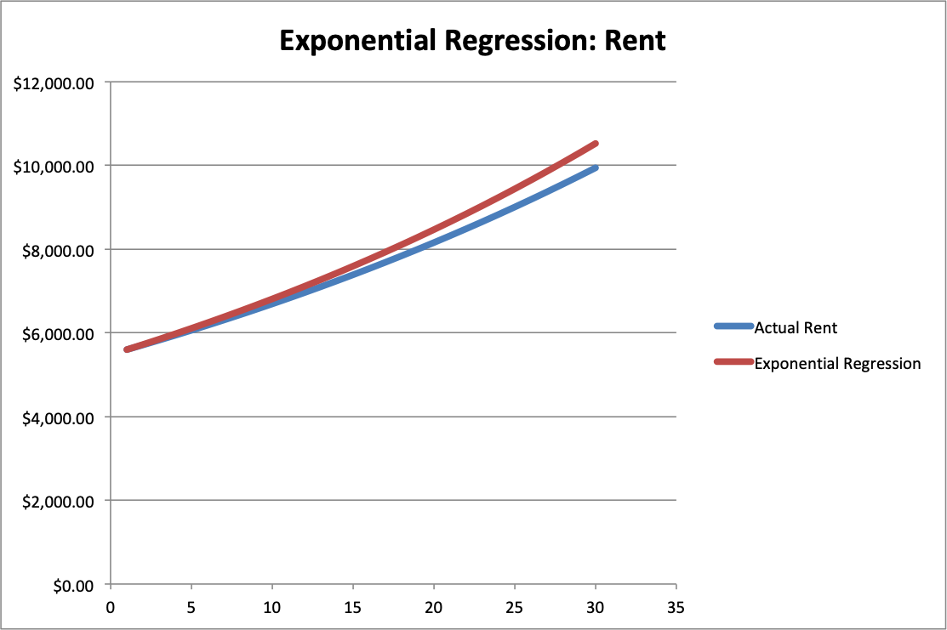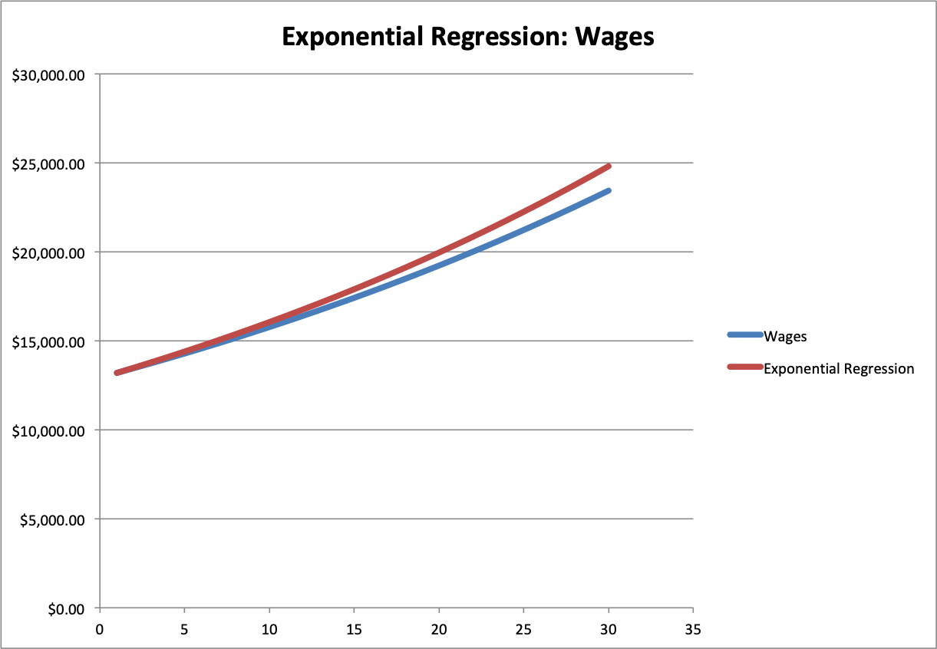

Figure-1: Exponential Regression for Rent Figure-2: Exponential Regression for Wages

Linear regression:

**Rent**: Y = a + b*X, **Wages**: Y = a + b*X,   
 where X = t - 1 where X = t - 1

Y = rent for next year Y = rent for next year

a = rent for year-1 a = wages for year-1

b = Increase per year = $100 b = Increase per year = $300

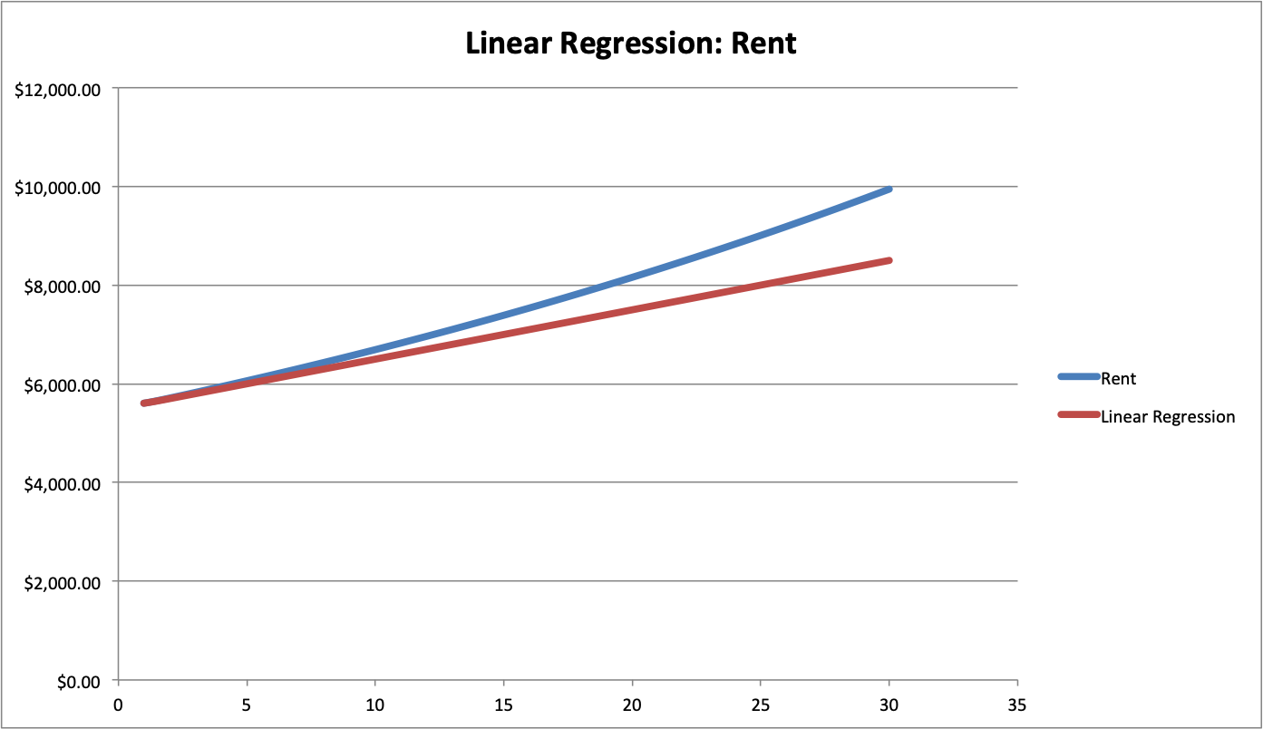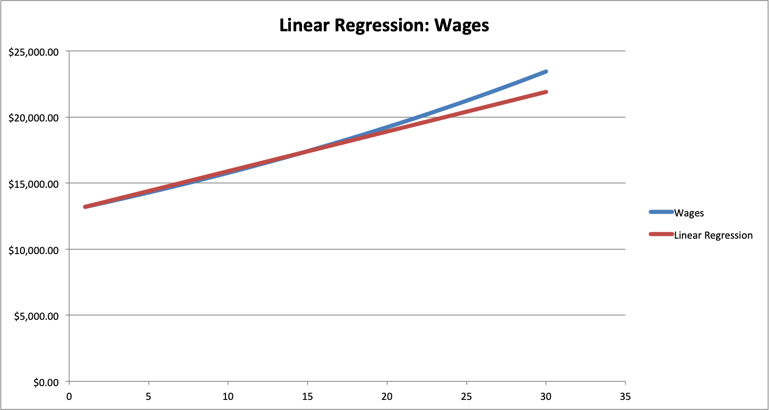

Figure-3: Linear Regression for Rent Figure-4: Linear Regression for Wages

# WACC

In order to obtain the capital of our initial investment, we used the following different resources are loan, Common Stock, Preferred Stock & Retained Earnings. We are assuming that the tax rate is 40%.

**Loan**: The interest rate is assumed to be 5% compounded annually from the bank. So, the effective rate is 5.00%, and thus, the cost of capital = 5% * (1 - 40%) = 3.00%.

**Common Stock**: The dividend per share (CSD) is $5, the current trading price per share (PCs) is $100, & the growth rate is assumed to be 4%. Thus, the cost of capital = $5 / $100 + 4% = 9.00%.

**Preferred Stock**: the dividend per share (PSD) is $7, the current trading price per share (PPs) is $100, & the Cps is $1. Thus, the cost of capital = $7 / ($100 - $1) = 7.0707%

**Retained Earnings**: The cost of capital = cost of capital of Common Stock = 9.00%.

**Table 2:** Source of Initial Investment

|  |  |  |
| --- | --- | --- |
|  | **Percentage** | **Cost of Capital** |
| **Loan** | 30.00% | 3.0000% |
| **Common Stock** | 40.00% | 9.0000% |
| **Preferred Stock** | 20.00% | 7.0707% |
| **Retained Earnings** | 10.00% | 9.0000% |

From **Table 2**, WACC = 30% * 3% + 40% * 9% + 20% * 7.0707% + 10% * 9% = 6.81414%. Our profit margin is set to be 2%, so our Before Tax MARR is 6.81414% + 2% = 8.81414%. We have assumed the income tax rate to be 40%. Thus, the **After Tax MARR** turns out to be = 5.28848%.

# PAYBACK METHOD

We are considering Plan-3 & Plan-4 for paying back the loan. The Lender’s rate is 5% compounded annually and the ATMARR is 5.28848%, which is equal to TVOM for us.

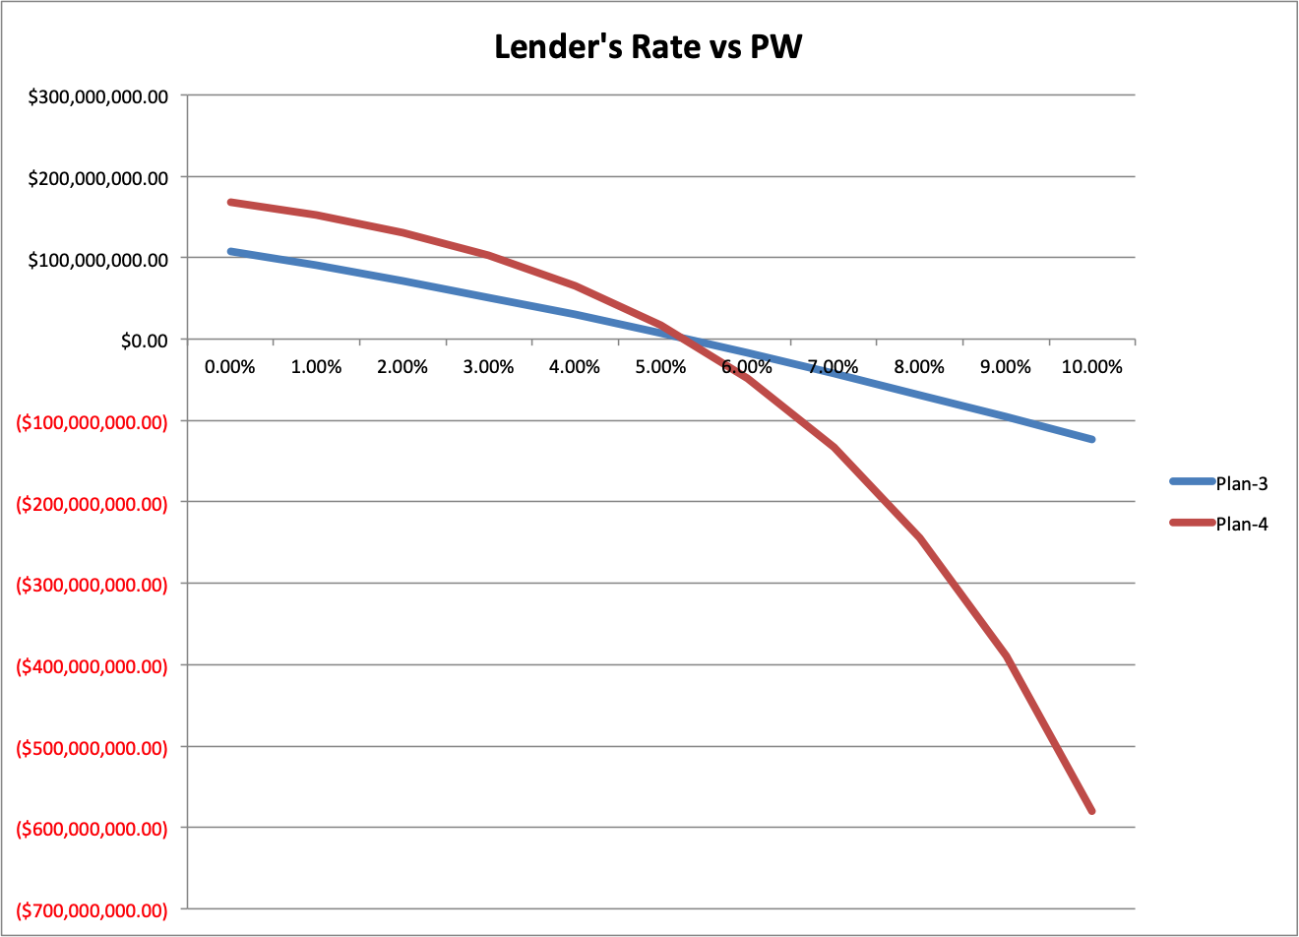

Figure-5: Lender’s Rate vs PW

As we can see from the graph, (i) if the lender's rate < TVOM, use plan-4 for borrowing.

(ii) if the lender's rate > TVOM, use plan-3 for borrowing.

Since the lender’s rate (5%) is less than the TVOM (5.29%), thus it is better for us to use Plan-4 for paying back the loan.

# DEPRECIATION

The two depreciation methods used in the project are Straight Line Depreciation (SLN) & MACRS-GDS.

The residential building is considered to be a 27.5-year residential rental property using mid-month convention and the mall & hotel are considered to be 39-year nonresidential property using mid-month convention.

We are assuming that the salvage value is a constant value and is equal to 30% of the initial investment.

# ECONOMIC PERFORMANCE

We use Present worth (PW) & Internal Rate of Revenue (IRR) as evaluation methods for after-tax analysis.

Residential Buildings

**Table 3:** After-Tax Present Worth for Residential Buildings

|  |  |  |  |  |
| --- | --- | --- | --- | --- |
|  | **SLN** | | **MACRS** | |
|  | **Plan-3** | **Plan-4** | **Plan-3** | **Plan-4** |
| **Uniform** | $43,832,485.57 | $66,840,102.43 | $74,745,204.21 | $97,752,821.07 |
| **Geometric** | $199,985,696.03 | $222,993,312.89 | $230,898,414.67 | $253,906,031.53 |

Mall

**Table 4:** After-Tax Present Worth for Mall

|  |  |  |  |  |
| --- | --- | --- | --- | --- |
|  | **SLN** | | **MACRS** | |
|  | **Plan-3** | **Plan-4** | **Plan-3** | **Plan-4** |
| **Uniform** | $32,693,923.38 | $36,799,191.34 | $33,649,088.73 | $53,923,981.43 |
| **Geometric** | $242,715,360.07 | $284,890,628.04 | $281,740,525.42 | $302,015,418.13 |

##### **Hotel**

**Table 5:** After-Tax Present Worth for Hotel

|  |  |  |  |  |
| --- | --- | --- | --- | --- |
|  | **SLN** | | **MACRS** | |
|  | **Plan-3** | **Plan-4** | **Plan-3** | **Plan-4** |
| **Uniform** | $61,409,790.65 | $65,117,148.48 | $62,272,374.96 | $65,979,732.79 |
| **Geometric** | $98,112,342.04 | $101,819,699.87 | $98,974,926.35 | $102,682,284.18 |

We observe the following:

1. Since lender's rate < MARR, thus we prefer to use Plan-4. Thus, the Present Worth calculated for Plan-4 is greater than the one for Plan-3.
2. The Present Worth for Geometric CF is greater than the Uniform CF. This is expected since the revenues are greater in geometric CF.

# SENSITIVITY ANALYSIS

The sensitivity analysis is done for only Residential Buildings. The 4 inputs taken into consideration are the initial investment, the marketing rate, the geometric increase rate & the rent (per apartment per month) in year-1.

**Table 6:** Distribution fitting for the different inputs

|  |  |  |  |  |
| --- | --- | --- | --- | --- |
|  | **Distribution** | **Parameter-1** | **Parameter-2** | **Parameter-3** |
| **Initial Investment** | Normal | $683,510,526.32 | $55,530,421.04 |  |
| **Marketing Rate** | Triangular | 44.00% | 70.00% | 85.00% |
| **Geometric Increase Rate** | Triangular | 2.00% | 8.00% | 10.00% |
| **Rent** | Normal | $5,761.90 | $677.11 |  |

##### **Risk Analysis**

The outputs for the risk analysis are PW, IRR & bonus. The simulation is run for 5000 iterations.

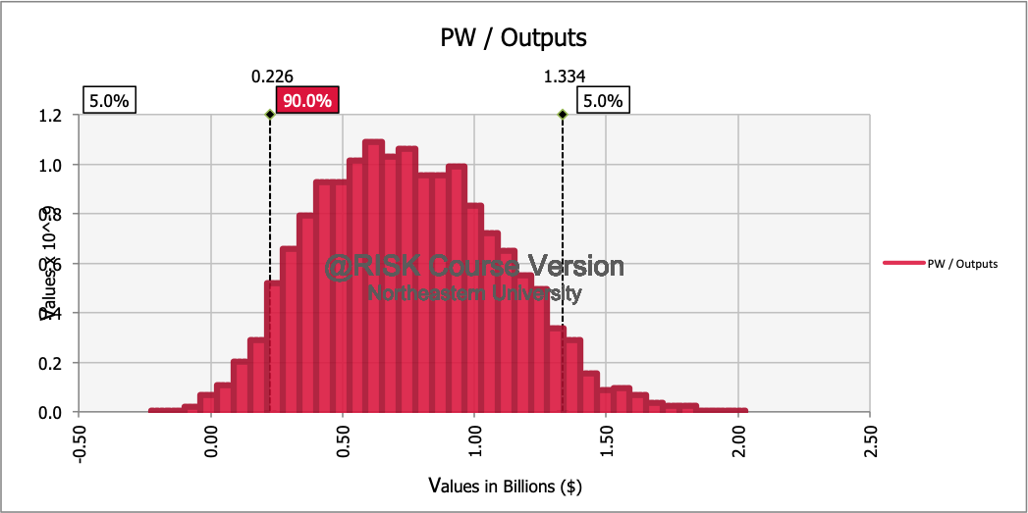

Figure-5: Present worth/output

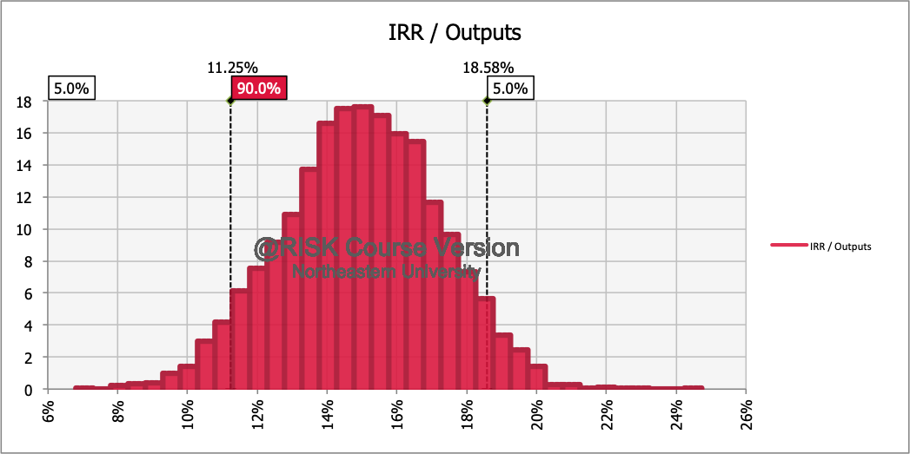

Figure-6: Internal Rate of Revenue/output

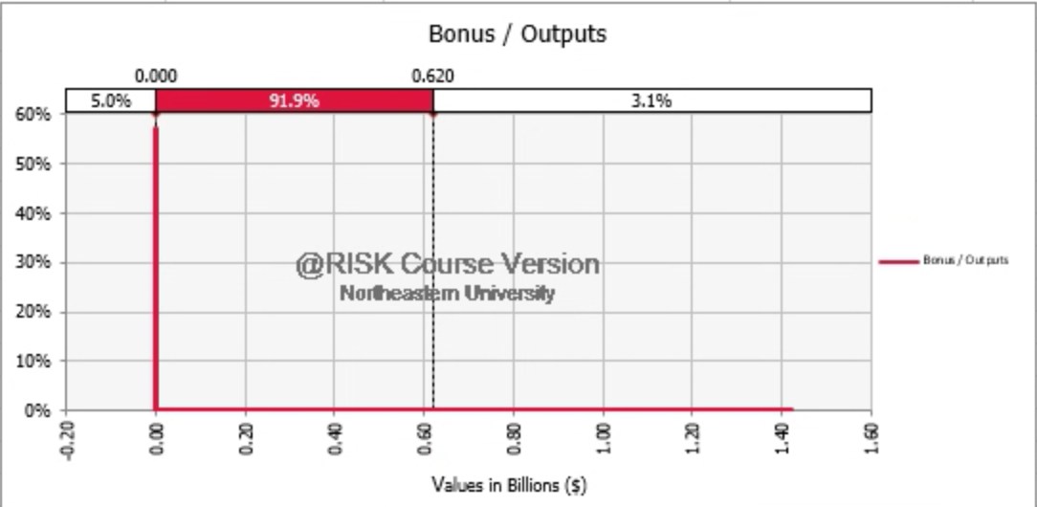

Figure-7: Bonus/output

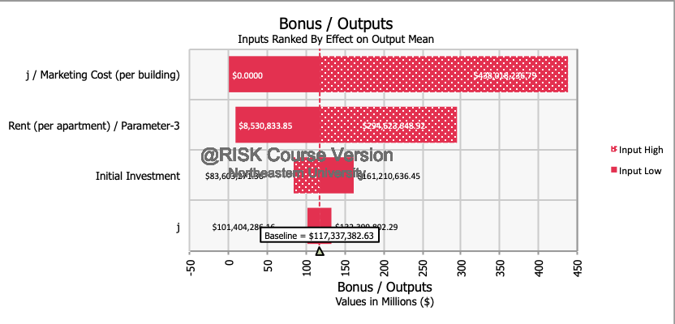

Figure-8: Factors affecting Bonus (or Profit)

# ANALYTIC HIERARCHY PROCESS (AHP) ANALYSIS

For the AHP Analysis, we have taken four factors into consideration to compare the three alternatives.

**Table 7:** Legend of the different alternatives & factors

|  |  |
| --- | --- |
| **Legend** | **Alternatives** |
| A | Residential Buildings |
| B | Mall |
| C | Hotel |

|  |  |
| --- | --- |
| **Legend** | **Factor** |
| 1 | Present Worth |
| 2 | Maintenance Fees |
| 3 | Customer Satisfaction |
| 4 | Waste Disposal |

**In AHP Analysis**: for each row, Priority Vector = Average of the individual cells in the row divided by the sum of each column.

### **Weighted Factor Comparison**

In Weighted Factor Comparison: Rate (i) = the priority vector of each alternative wrt the factor (i)

Score (i) = Weight (i) * Rate (i)

Total Score = summation of all score (i)

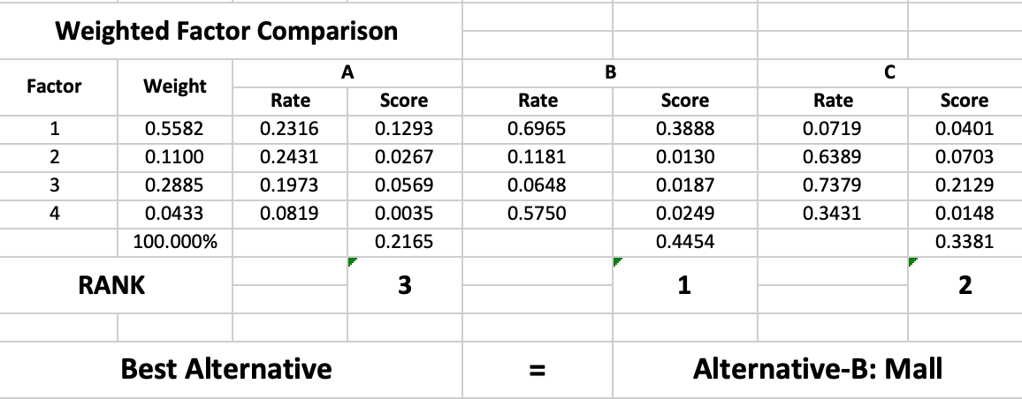

Figure-7: Weighted Factor Comparison Table

**Table 8:** Total score for the alternatives

|  |  |
| --- | --- |
| **Alternative** | **Total Score** |
| Residential Buildings | 0.2165 |
| Mall | 0.4454 |
| Hotel | 0.3381 |

As we can see, the highest total score is for Mall. Thus, it is the most beneficial for the corporation to build a Mall as it serves our interest the most.

# CONCLUSION

After conducting the AHP Analysis & the Weighted Factor Comparison, we have reached the conclusion that it is the most beneficial for the corporation to construct a Mall, followed by a Hotel, & then Residential Building. Mall has the highest present worth in all of the cases considered. Since profit is a major requirement for any corporation, constructing a Mall would result in larger profits.

# REFERENCE

1. https://www.proest.com/apartment-building-construction-cost-breakdown/
2. https://www.thebalance.com/home-maintenance-budget-453820
3. http://blog.rismedia.com/2018/apartment-maintenance-costs/
4. https://www.naahq.org/news-publications/units/august-2016/article/2016-naa-survey-operating-income-expenses-rental
5. Triantaphyllou, E. & Mann, S.H (1995). Using the Analytic Hierarchy Process for Decision Making in Engineering Applications: Some Challenges. Inter’l Journal of Industrial Engineering: Applications and Practice, Vol. 2, No. 1, pp. 35-44, 1995
6. EMGT6225 40505 Economic Decision Making SEC 02 Summer 1 2019 [BOS-2-TR] (EMGT6225.40505.201940): Course Material
7. https://www.scribd.com/document/86642580/Costs-of-Build-Shopping-Mall
8. https://www.camoinassociates.com/average-square-footage-and-retail-sales-square-foot-across-major-brands
9. https://www.fixr.com/costs/build-parking-garage#cQ
10. https://www.loopnet.com/for-lease/boston-ma/generalretail/?sk=b10cc19dbdd6ac99013f89318e4a1cc7
11. https://www.fixr.com/costs/build-hotel
12. https://lifehacker.com/how-hotel-prices-vary-by-season-across-the-united-state-1710934286
13. https://www.quora.com/What-are-some-of-the-biggest-expenses-in-the-hotel-business

# APPENDIX

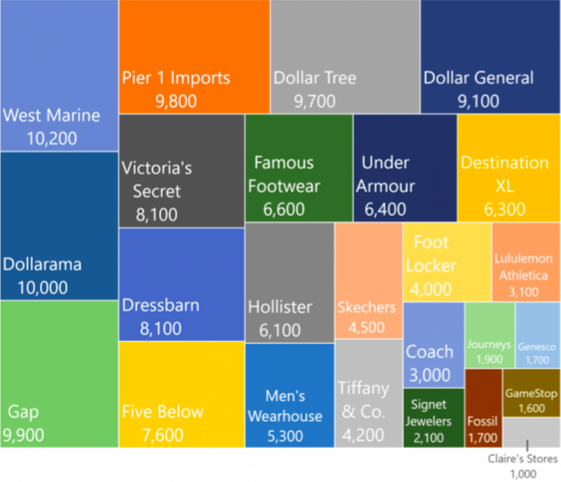

Graph 1: Average Store Area of Retailing Stores